**22**

**3**

**LAPORAN PRAKTIKUM**

**ALGORITMA DAN PEMROGRAMAN**

**Pertemuan Ke- 4**



**Disusun Oleh :**

|  |  |
| --- | --- |
| **NAMA** | **: NANANG SETYAWAN** |
| **NIM** | **: 185410025** |
| **JURUSAN** | **: Teknik Informatika** |
| **JENJANG** | **: S1** |

**STMIK AKAKOM**

**YOGYAKARTA**

**2018**

Nama : Nanang Setyawan

NIM : 185410025

Kelas : TI 1

ALGORITMA DAN PEMROGRAMAN

PERTEMUAN KE-4

**PRAKTIK 1**

1. Open documentation in string class

<http://docs.oracle.com/javase/8/docs/api>

1. Explain string class documentation

**PRAKTIK 2**

1. Using method length

public class LatihanString1{

public static void main(String[]args){

String name = "Nanang.S";

System.out.println(name.length());

}

}

Output:

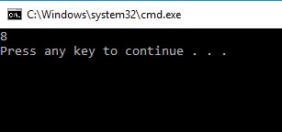

Explanation :

This code teach us to count string length

We can see at the output, its show 8 because string name Nanang.s has 8 alphabet

And the system.out.println is name length, so output is total alphabet in nanang.s word

1. Access each character in string

public class LatihanString2{

public static void main(String[]args){

String str= "Hello, Nanang";

System.out.println(str.charAt(0));

System.out.println(str.charAt(1));

System.out.println(str.charAt(2));

System.out.println(str.charAt(3));

System.out.println(str.charAt(4));

System.out.println(str.charAt(5));

System.out.println(str.charAt(6));

System.out.println(str.charAt(7));

System.out.println(str.charAt(8));

System.out.println(str.charAt(9));

System.out.println(str.charAt(10));

System.out.println(str.charAt(11));

System.out.println(str.charAt(12));

}

}

Output :

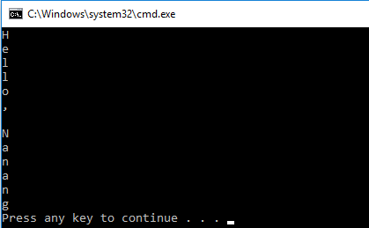

Explanation :

This code is little similar from the first code that we are asked to count alphabet. But in this code, its show one alphabet in one line. So if there are 12 alphabet, it will show 12 line in output. As we can see in screenshot above. Hello, nanang has 12 character or alphabet.

1. Take index value from character in string

public class LatihanString3{

public static void main(String[]args){

String phoneNum= "0823-9473-669";

int idx1= phoneNum.indexOf('-');

System.out.println("index of first dash: "+idx1);

int idx2= phoneNum.indexOf('-',4);

System.out.println("second dash index: "+idx2);

}

}

Output :

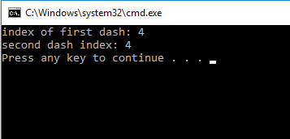

Explanation :

In this code we will count the character or alphabet before – symbols.

So in screenshot above, it show index of first dash:4 and second dash index:4

So we can conclude that 4 take from the number character 0823-9473.

1. Take substring from string

public class LatihanString4{

public static void main(String[]args){

String greeting= "Hello, world";

String sub= greeting.substring(0,5);

System.out.println(sub);

String w= greeting.substring(7,11);

System.out.println(w);

String tail= greeting.substring(7);

System.out.println(tail);

}

}

Output :

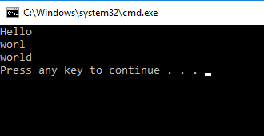

Explanation:

This code asked us to take substring from string.

Its mean from the string we can show little or less from the sentence.

In this case we use hello world sentence. At first output we take substring 0,5 and the output take 5 first sentence. Second it use 7,11 so the output must be 7th character till 11th which is the character is worl. Third the output use 7 so the output from 7th character or alphabet till end.

1. Change character in string

public class LatihanString5{

public static void main(String[]args){

String str="Using String replace to replace character";

String newStr= str.replace("r","R");

System.out.println(newStr);

}

}

Output :

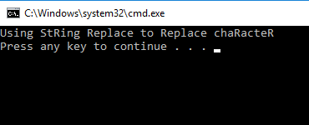

Explanation :

This code asked us to change character from string, but in this case we will change

“r” to “R”, so in the sentence using string to replace character, all the “r” change to “R”.

As we can see in picture above the character has changed

1. Change character to string

public class LatihanString55{

public static void main(String[]args){

String str="Using String replace to replace character";

String newStr= str.replace("r","R");

System.out.println(newStr);

String newFirstStr= str.replaceFirst("re","RE");

System.out.println(newFirstStr);

}

}

Output :

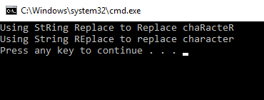

Explanation :

This code is look similar from the previous code that asked chane “r” to “R”, but in this code we add some output to change “re” become “RE”. so the output will similar but “re” character will change to capital letter or alphabet.

1. Declarate and make string

public class LatihanString6{

public static void main(String[]args){

String s1= "Susan";

String s2= "Robert";

s1= s1+s2;

System.out.println(s1);

}

}

Output :

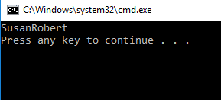

Explanation :

In this code we asked to declarate and making string. So we input s1 string and s2 string.

In output system.out.println it declarate s1 but why in picture above show s1 and s2 variable. Its because in code above before output we write s1=s1+s2, so the output is s1 and s2.

1. Combine string

public class LatihanString7{

public static void main(String[]args){

String newString= "Learning Java"+8;

System.out.println(newString);

String newString1="8"+8;

System.out.println(newString1);

}

}

Output :

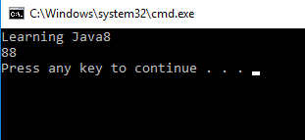

Explanation:

In this code we asked to combine string.

In this case we use 8. As we can see above string newString1 has “8”+8 value so the output show 88 because it combine 8 and 8. And we have to know its combine, not sum or add

1. Use concat method

public class LatihanString8{

public static void main(String[]args){

String myString= "Hello";

myString= myString.concat("World");

System.out.println(myString);

}

}

Output :

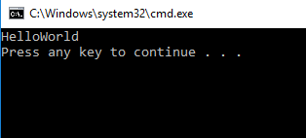

Explanation :

In this code we asked to combine string.

At fisrt myString+ “Hello” and second my string”world”

And output my string. So with code above we know that concat use to combine string or character.

1. Compare method

public class LatihanString9{

public static void main(String[]args){

String s1= "Susan";

String s2= "Susan";

String s3= "Robert";

//Return 0 because s1 is identical to s2

System.out.println(s1.compareTo(s2));

//Return >0 because 'S' follow 'R';

System.out.println(s1.compareTo(s3));

//Return <0 becouse 'R' precedes 'S'

System.out.println(s3.compareTo(s1));

}

}

Output :

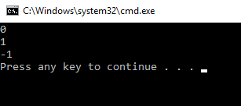

Explanation:

In this output we will compare some value from variable.

First compare s1 to s2 that mean compare susan and susan. Because it same character and alphabet so the output 0.

Second compare s1 to s3 that mean susan to Robert. “S” is 19th in alphabet and “R” in 18th alphabet so 19-18=1, so the output is 1

Third compare s3 to s1 that mean Robert to susan. “R” is 18th in alphabet and “S” in 19th in alphabet. So 18-19=-1, so the output is -1

**PRAKTIK 3**

1. Use random number by integer type

import java.util.Random;

public class LatihanRandom1{

public static void main(String[]args){

Random rndNum= new Random();

int randomNum= rndNum.nextInt();

System.out.println("Random Number: "+ randomNum);

}

}

Output :

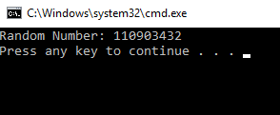

Explanation :

This code asked us to show random number by integer.

rndNum variable has new random value.

System.out.println will show random number as we can see in picture above.

If we repeat to compile and run it, the output will show different number because it random.

1. Make a random number

import java.util.Random;

public class LatihanRandom2{

public static void main(String[]args){

Random num= new Random();

System.out.println("Random Number 1:"+ num.nextInt());

System.out.println("Random Number 2:"+ num.nextInt());

System.out.println("Random Number 3:"+ num.nextInt());

System.out.println("Random Number 4:"+ num.nextInt());

System.out.println("Random Number 5:"+ num.nextInt());

}

}

Output :

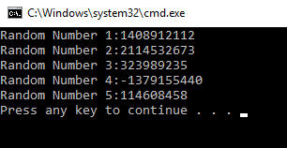

Explanation :

This program is similar with previous program but in this program we use 5 output that in each output will show different number. If we repeat to run it the 1st 2nd 3rd 4th 5th output will show different number.

1. Use double random number

import java.util.Random;

public class LatihanRandom3{

public static void main(String[]args){

Random num= new Random();

double randomNum= num.nextDouble();

System.out.println("Random Number:"+ randomNum);

}

}

Output :

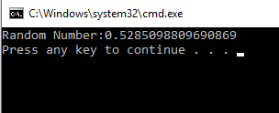

Explanation:

This program is to make random number with double data type. So the output must be a decimal number. And as we can see at the output it show 0,5 bla bla bla. But the code similar from using random in integer data type. Different just the data type. In previous program use integer but in here use double.

1. Make random character with range

import java.util.Random;

import java.util.Scanner;

public class Lottery{

public static void main(String[]args){

Scanner numberScanner= new Scanner(System.in);

System.out.println("Enter a number between 1 and 10:");

int userNum= numberScanner.nextInt();

Random rnd= new Random();

int winningNum= rnd.nextInt(10)+1;

System.out.println("Your number:"+ userNum);

System.out.println("The winning number is:"+ winningNum);

}

}

Output :

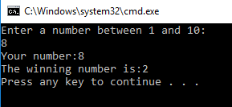

Explanation :

This program I don’t really understand, but in my opinion this is for random lottery as the class name. so we asked to input number from 1 till 10 then we asked to input it and the winning random number will appear. But I don’t know why 2 is the winning number. May be because it random.

**PRAKTIK 4**

1. Use sqrt method

public class LatihanMath{

public static void main(String[]args){

System.out.println(Math.sqrt(121.0));

}

}

Output :

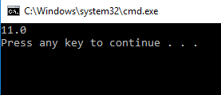

Explanation :

This code asked us to use sqrt method.

The system.out.println or output is math.sqrt(121.0)

And output is 11 because 112 or eleventh squared is 121.

It decimal because we use double data type in this code.

1. Use min and abs method

public class LatihanMath2{

public static void main(String[]args){

double result= Math.min(3,7)+ Math.abs(-50);

System.out.println("Result is " + result);

}

}

Output :

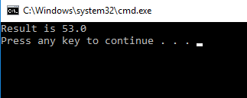

Explanation :

In this program asked to use min and abs.

It use double data type. Math.min 3 and 7, so we choose 3 because math.min and we choose minimum number. Then for abs -50 so we choose the positive number than we choose 50. We add them for result in output. 3+50=53. Look at picture above, the output is 53.0. it use decimal because we ude double data type.

1. Use PI field

import java.util.Scanner;

public class AreaOfCircle{

public static void main(String[]args){

Scanner sc= new Scanner(System.in);

System.out.println("Enter the radius:");

double radius= sc.nextDouble();

double area= Math.PI*radius*radius;

System.out.println("The area of circle is: "+ area);

}

}

Output :

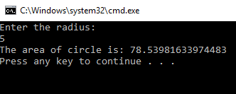

Explanation :

In this code we asked to search area of circle.

Then the formula is Math.PI*radius*radius, so we can change it to number.

3.14*5*5= 78.5. in input keyboard I enter 5 so the formula is multiple 5 twice.

**LATIHAN**

1. Count BMI (Body Mass Index) with formula

import java.util.Scanner;

public class Latihan{

public static void main(String[]args){

double weight, height;

double BMI;

Scanner input= new Scanner (System.in);

System.out.print("Enter your weight in pounds:");

weight=(int)input.nextDouble();

System.out.print("Enter your height in inches:");

height=(int)input.nextDouble();

height= Math.pow(height,2);

BMI= ((weight*70)/height);

System.out.println("Your body mass index is "+ BMI);

}

}

Output:

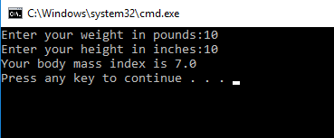

Explanation :

In this code we asked to search body mass index with input weight and height. And in this code we use java.util.scanner to input keyboard. We search body mass index(BMI) with this formula

BMI=weight/height2*70. In this case I input height=10, weight=10. So 10/100*70=7.0. its decimal because we use double data type.

**Conclution:**

in this practice we know how to see character in string, combine value, index, input keyboard in output and we know how to search something by a formula in the code.